Bug #1 — N+1 Queries in UsersController#index

Issue

The **/users** endpoint calculated **products_count** using:

**user.products.count**

This caused an N+1 query problem, where Rails executed one query to load users and an additional query per user to count products. This results in poor performance as the dataset grows.

Fix

I replaced per-user counting with a single aggregated query using **LEFT JOIN** and **GROUP BY**.

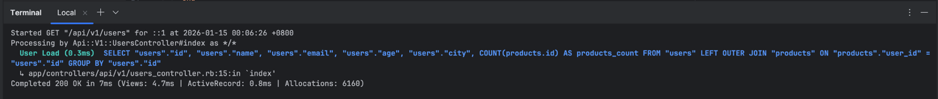

Bug #2 — N+1 Queries in ProductsController#index

Issue

**user_info = User.find(product.user_id)**

This ignores includes(:user) and causes 1 query per product.

Fix

Use the already-loaded product.user

Bug #3 — Inefficient Collection Logic for is_expensive

Issue

The products endpoint:

* Iterated through all products to build an array of expensive product IDs
* Performed duplicate checks using **include?**

Fix

Use the database-level filtering and the existing scope: **Product.expensive**

Bug #4 — Wrong Data Type in Query

Issue

The query used a string conversion for **user_id**, but **user_id** is integer.

**Product.where("user_id = ?", params[:id].to_s)**

This caused unnecessary type casting and could lead to inefficient query plans.

Fix

Replaced it with query: **@user.products**

Bug #5 — Weather Temperature Unit Assumption

Issue

Mock data mixes Fahrenheit (US cities) and Celsius (EU cities)  
But code assumes everything is Celsius

**temperature_celsius: temperature**

This produces wrong results

Fix

Normalize temperatures properly:

* US cities → Fahrenheit → convert to Celsius
* EU cities → already Celsius

Bug #6 — Data Security Improvement

Issue

Data exposure on user endpoint. This exposes all columns.

Fix

Explicit JSON response.

Bug #7 — Error handling improvement on WeatherController

Issue

When searching invalid city, it will still response as valid city

Fix

Adding timeout condition on weather service for weather service unavailable 503 and if any unknown city, it will return nil or invalid data weather 502.

